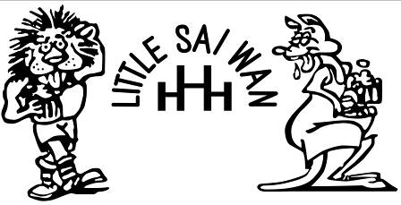
*******************LSW 11th HASH REUNION HASH NEWS****************
1 - 3 June 2018
Amsterdam
HARE – Slippery Edge
LSW Run Nos 2171 and 2172
RECEDING HARELINE
2019 5-8 July Portsmouth, UK HARES – Cyclops , Headlamp and Little Einstein
2020 Glasgow HARES – Mensa, Shanghai and Tai O
2021 Pau, France HARE – Shergar
2022 Chepstow, UK HARE – Stickman and Bare Arse
NEXT YEARS RUN
2019 This will be held in Portsmouth on Friday 5 July to Monday 8 July. Cyclops will email details in due course.
2018 ATTENDEES

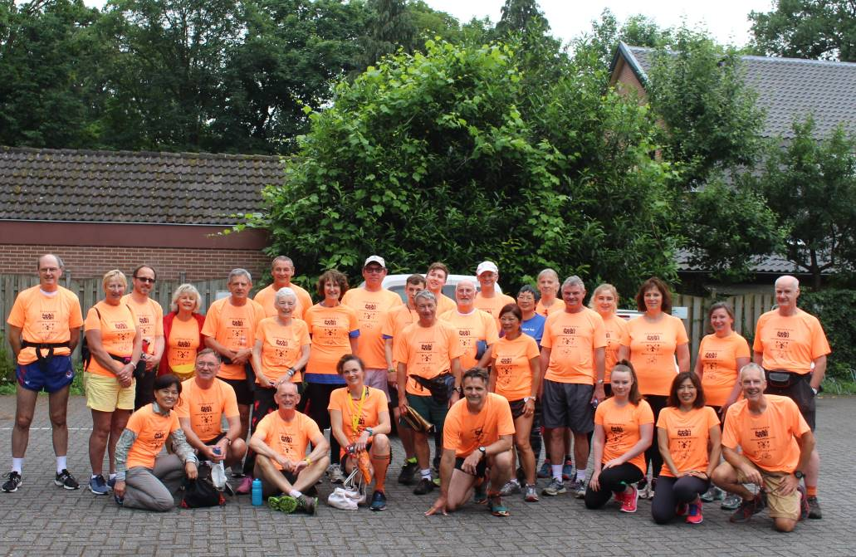

Peter Bourton – Peterfile Clive Posford - Becks
Adrian Buckman - Special Branch Sarah Morley - Posh
Neil Thomason – Cyclops Simon Aldridge - Buzzard
Kimi Thomason – Headlamp Eva Aldridge – 35 cents
Mike Cowan - Ballbuster Karen Hedderman - Legolass
Annie Ng Nigel Powell - Stickman
Colin Etheridge - Hash Horn Maggie - Bare Arse
Denise Etheridge - Dame Edna Lisa Boyle – Slippery Edge
Eric McLeod – Hash Cash
Seonaid McLeod – Big Bitch
Alan Grant - Mensa
Jill Sutcliffe - Shanghai
Jackie Grant - Tai O
Sandy Grant
Greg
Chris Moorhead – Mensa’s Bitch
Colin Jones - Taipo
Sue Jones - Twinkletoes
Callum Jones - Speedy
Stuart Gethin – Mr Happy Slippers
Hayden Davies – Vulcan
Cathy Davies – Droptop

RUN 2171 SATURDAY 2 JUNE 2018 DRIEBERGEN, AMSTERDAM
WRITEUP – Posh

We met up late Saturday morning for the bus to take us out to out into the countryside for the first run. The meet up was outside the Amsterdam Hilton made famous as the hotel where John Lennon and Yoko Ono honeymooned and held a week long 'Bed In' for World Peace nearly 50 years ago. No one managed to guess which of the many windows was 'the room'. For the culturally discerning, there was also an original Auguste Rodin sculpture of 'The Thinker' in the garden next to the hotel.
After a scenic trip down the motorway past Utrecht the driver got lost. He needed the able assistance of Tai Po, in contact with Hare, Slippery Edge by mobile and then Vulcan to see him back as he negotiated an about turn by the local fire station. We finally arrived at the On On, a pancake house in Dreibergen to be met by Slippery Edge and visitors from the Amsterdam and Hague hashes.
After the usual obligatory group photo Slippery Edge gave us a particularly long chalk talk where she explained the use of non-Sai Wan markings (with - no Ts to check back and open arrows) as she had forgotten these.
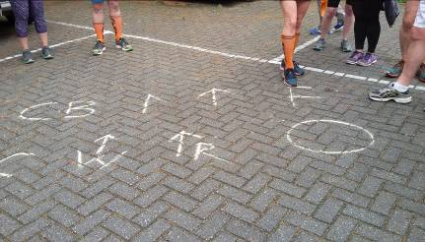 Non LSW Markings
Then with suitable warbling from Hash Horn we were off along the cycle path, negotiating our way past the Dutch bikes and scooters. We had a short impromptu muster at the level crossing while a train went by, and shortly thereafter we were in the forest..
There were forest trails and more forest trails - all very well marked in sawdust and non LSW arrows.
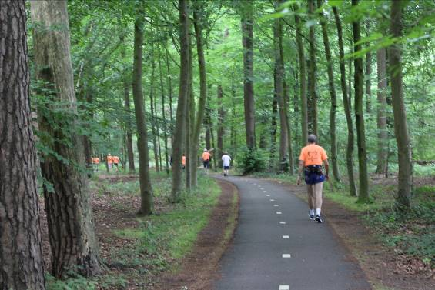 The markings and the number of people wearing the bright orange reunion hash tee shirts made it virtually impossible to get lost on trail. After a while a Wimps/Rambos split appeared.. The Rambos was a large loop through the forest and then around a village. A board in the village square told us ( in Dutch of course) that the village stood on the site of a large camp, called Austerlitz, named after the battle of the same name, where one of Napolean's generals had stationed his troops for a summer. To stop his troops getting bored the army were set to work building a huge mound of mud which became known as 'The Pyramid of Austerlitz'. We did not get to run around the pyramid but did see some of the locals - said to be descended from the results of the troops other entertainment. After the Rambos loop we rejoined the route with the Wimps.
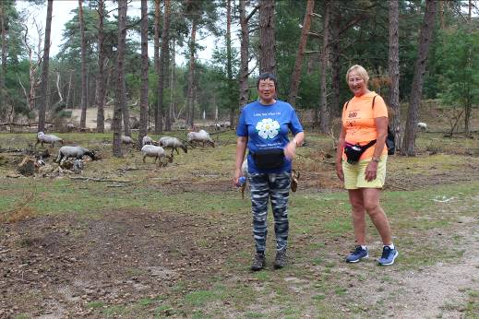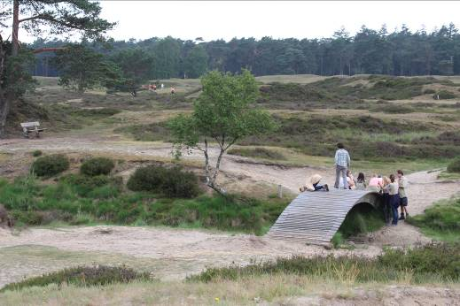
There was a brief encounter with some goats who thankfully kept their horns to themselves, then the chance for some sand between our toes with a sandy area and large pine trees a bit like the Hundred Acre Wood in 'Winnie The Pooh'. Then onto a bridge over a disused railway track which had a ginormous puddle right across it. We did not get to play 'pooh sticks' but for some the challenge was how to get across while still keeping the toes dry - heel walking, scaling the sides of the bridge etc. Down downs later for such assiduous puddle avoidance.
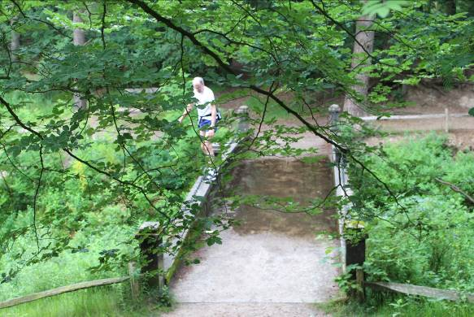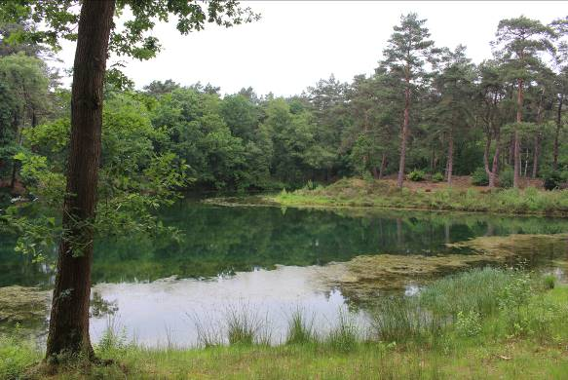
Puddle avoidance by Cyclops
The last part of the run took us all around a beautiful small lake with rhododendrons still in bloom. More forest and then through the garden of a large stately house, then a path through a forest of rhododendrons and finally we arrived at the pancake house. We had been out for two hours. The Rambos run was around 7 miles, the Wimps a little shorter, but a very enjoyable forest trail all in all.
Down Downs were awarded by Big Bitch who seemed to have something to say about everyone. More than one song was rendered, due to the Dutch influence. There was a poetry recital, courtesy of Vulcan and Bare Arse. A three course meal, without a pancake in sight, was enjoyed by all, after which we returned to Amsterdam, where some OnOnOning went on at the Wildshut.
Down Downs were as follows:-
Cyclops – wanting to know in May 2017 when the Amsterdam Hash was so he could book flights
Cyclops – sent email suggesting a 8 bedroom hotel in Chichester for his 2019 Reunion Run
Cyclops – sent another email changing venue to Portsmouth and the Holiday Inn as more than 8 bedrooms, taking forward planning to the extreme
Mensa – for no forward planning for Glasgow 2020
Slippery Edge – for the Non LSW markings
Hash Horn, Dame Edna, Taipo and Twinkletoes – sending Whatapps and disturbing Big Bitch’s golf on Thursday
Buzzard and 35 cents – choosing to celebrate Wedding Anniversary in Amsterdam, 16 years after John Lennon so 33 years
Stickman – only attends reunions every 5 years
Jackie – left her boyfriend at home as he’s too new
Greg – Sandy’s boyfriend for first run
Mensa – said LSW ran on Tuesday nights
Slippery Edge – giving bus driver wrong directions
Vulcan – bus monitor
Petafile – confusion with the hotel doors
Cyclops – unavoidable puddle
Chris – the Interloper, named as Mensa’s bitch
Posh, Becks and happy Slippers – child neglect
Dame Edna, Jackie and Bare Arse – new shoes
Slippery Edge – boasting about Amsterdam’s water being the best
The Scots didn’t agree – Happy Slippers, Hash Cash, Big Bitch, Mensa, Mensa’s bitch, Taipo, Jackie. Sandy and Greg
Ballbuster – furthest to travel from Qatar
Droptop – living up to her name and dropping the strawberries
Hash cash and Headhunter – organising a Golf Competition for next years reunion
Speedy – 3rd back behind the old farts. Hash Cash and Grandad
Last In – Hash Horn and Petafile
Petafile – no longer after young boys now after 60 year olds.

An interruption from the fat Dutchman who objected to us not singing songs as we were doing the Down Downs prompted the singing of the Hash Song which shut him up.

SUNDAY 3 JUNE 2018 RUN 2172
Write up – Hash cash

Run Start 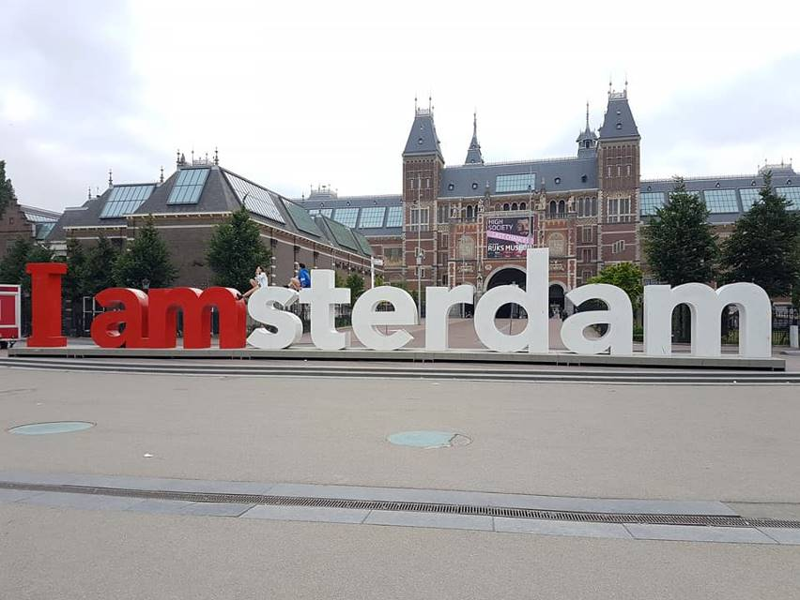
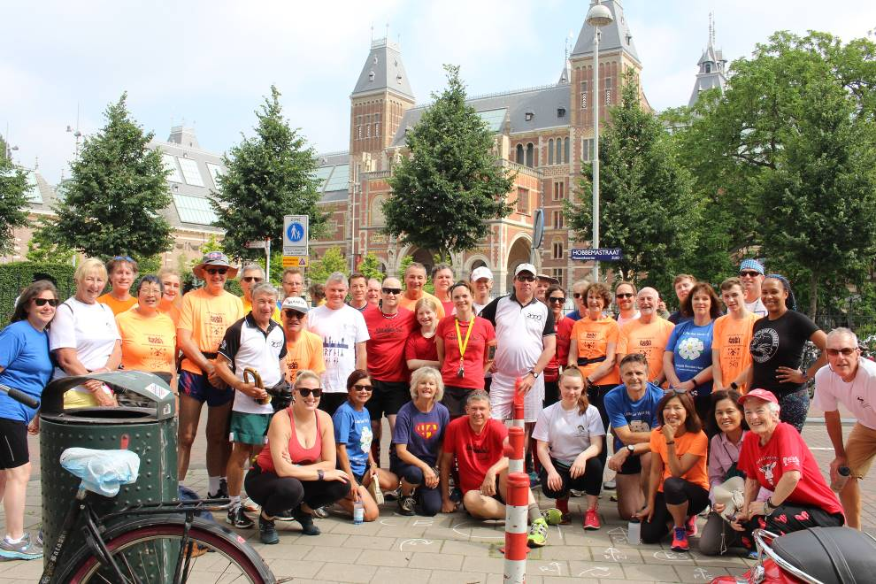 Sunday Runners
Remember Thursday mornings in Hong Kong. (Ed’s note Mensa thought it was Wednesday mornings, How many runs has he done!?)
The sore head. The sick feeling. Oh the Thursday morning hangover and knowing that you had to do the hash writeup. Office door closed. The secretary told that you are extremely busy and cannot be disturbed. A quick nap to hopefully get the brain into gear and then the creative thinking on where we ran last night. But it was easy there because you knew where you had run. The only difficult bit was getting the secretary to type up the Hash News and to try not to upset her with all the hashers names such as The Bastard, Any Fanny Will Do, Dogs Bollocks and Big Bitch. My secretary never could understand how my wife was a big bitch.
So anyway it is not Thursday morning in Hong Kong and I am not too damaged. However it is my own time and I am not wasting company time writing up the hash news. It is my time and I should be on the golf course, getting practice in for the first LSW Reunion Golf Competition in Portsmouth next year. Why did Big Bitch not find some other poor sod to do the Sunday writeup!
Well onto the run. 11 o’clock sharpish the Hashers gathered at the I Amsterdam sign next to the Rijksmuseum. After a short briefing and an explanation of the LSW markings used on the run, we were off .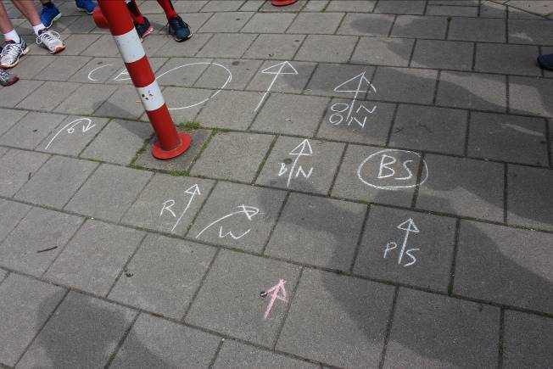 LSW markings.
Slippery Edge had unbelievably forgotten how LSW runs were marked the day previously.
With LSW hashers in the majority, (there were Amsterdam hashers but we outnumbered them by a fair margin) we set off through the Sunday market and the Rijksmuseum to our first crossing of a nullah and a very stupid Amsterdam hash marking that sent the first 6 hashers back to the back of the pack.
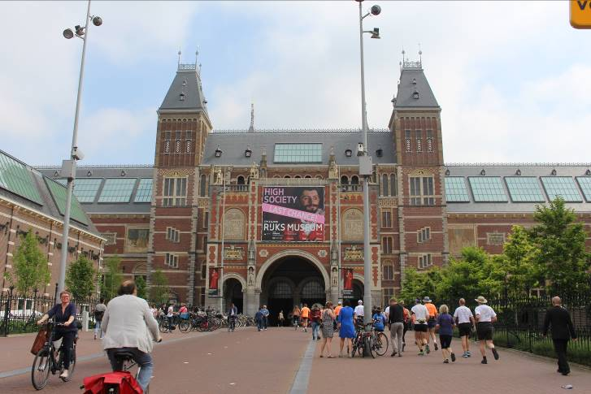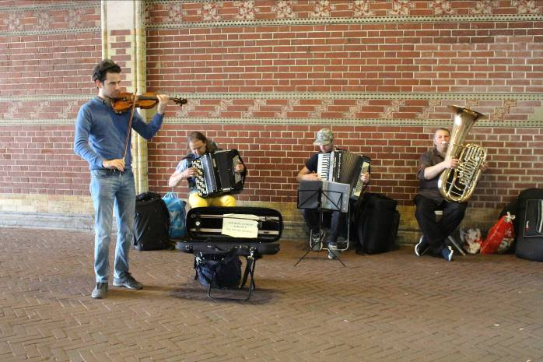
We ran across another few nullahs before I realised that they were actually canals because they didn’t stink like in Hong Kong and into a kids playpark where the markings directed us over a kids play area complete with zip-line.
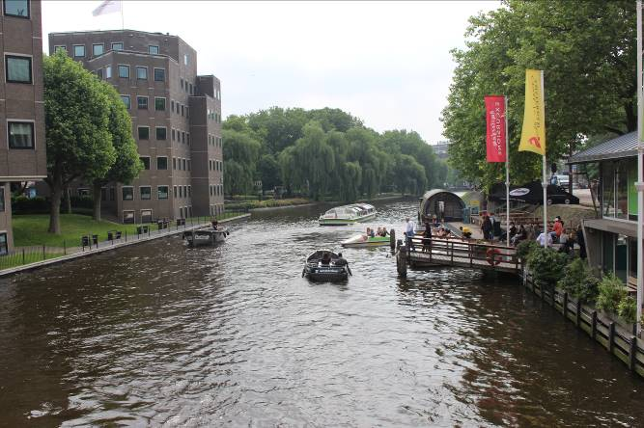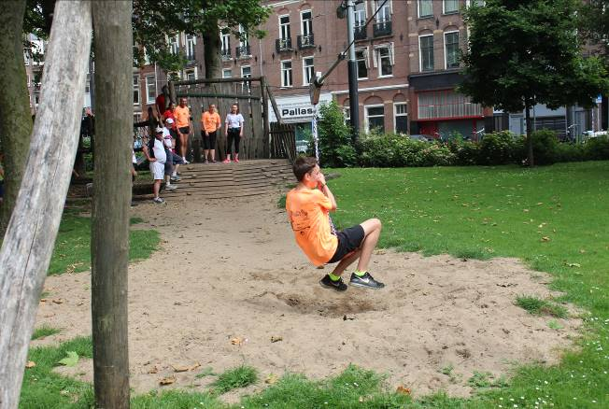
I hear that a few hashers grounded on their bottoms at this point.
On On we went across another few canals before we passed the Heineken Brewery where I thought the beer stop might be before eventually getting to the beer stop at the Windmill with no hare and no beer in sight.
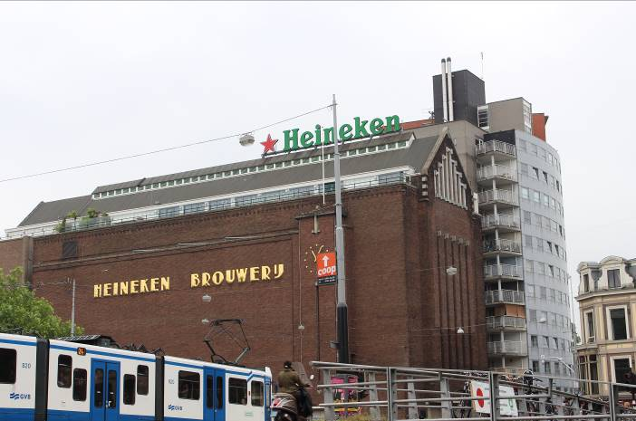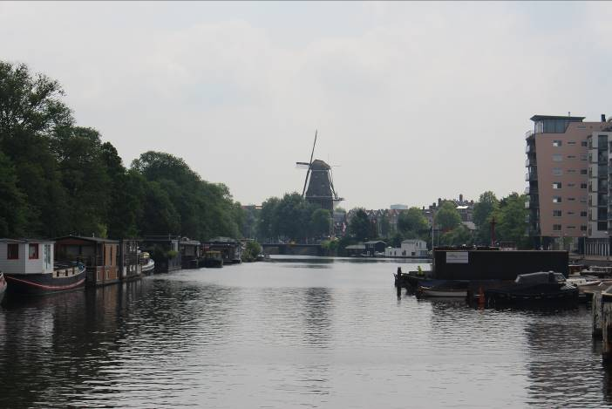
Mr Happy Slippers missed the beer stop as he had an early flight to catch but looked as if he had some of the beers in his rucksack which he carried round the trail. There was a toilet at a nearby café, so many hashers spent time getting rid of the previous nights beer before they topped up their beer levels again when the hare arrived on her bike with all the hash beer.
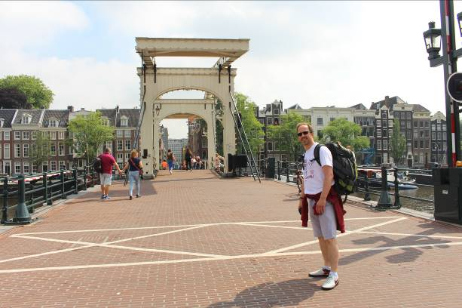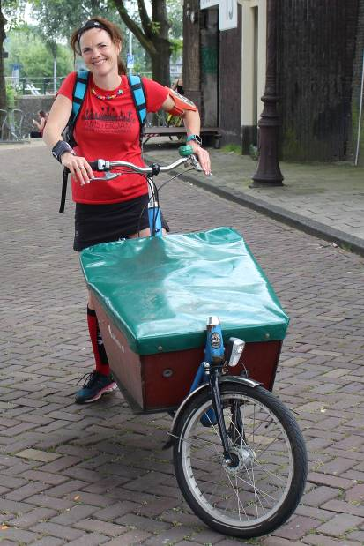
A hash photo was taken on the pier steps by the guy sitting in his speedboat before he buggered off in his flash black speedboat. It had to be a flash boat as the owner had the stupidest haircut that I have seen for a long time. He must have used the smallest pudding bowl to cut it to the shape it was.
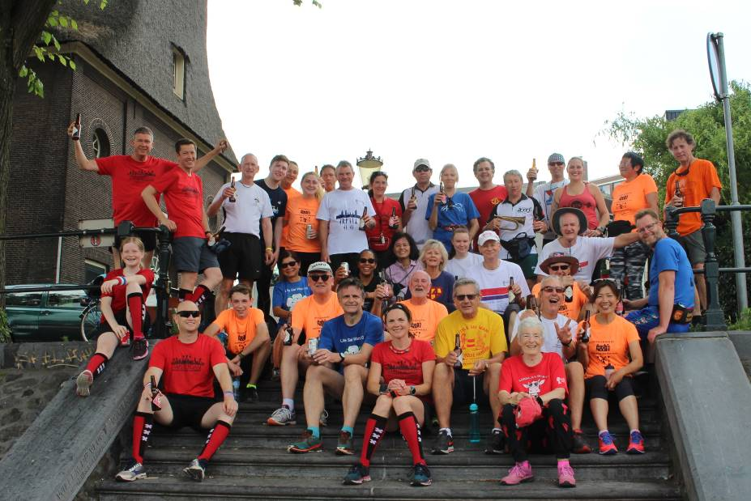

With new beer weighing down our legs, off we set for the second half of the run. Down some more narrow streets and across more nullahs then through the red light area where windows were full of ladies in their finest Sunday clothes trying to drum up customers. Greg was running so fast trying to catch up with Speedy that he missed all the window action. Finally we were back to the bins. Speedy and Greg were first back making sure they weren’t embarrassed by the old farts that beat them the previous day.
A great run and surprisingly in Holland, flat on average.
Confusion reigned at the Circle as the Amsterdam RA tried to give Down Downs but was continually interrupted by one Septic or another.
Vulcan then gave Down Downs for LSW as follows :-
AH3 RA for being a lookalike hare and having her hobby printed on her hockey skirt 'Head'
Peterfile for being the last in on Saturday's run and the last to get on the coach back and for crashing the beer bike on the in trail today.
Speedy for living up to his name and being first back.
Hash Horn for being a poser by having his photo taken next to a statue of a trumpet player.
Mensa for low flying on the zip wire.
Drop Top for showing off - the horn and ambulance both B flat.
Legolass for not knowing which way to go as she was standing on the trail arrow.
All the 'Septics' for monopolising the circle.
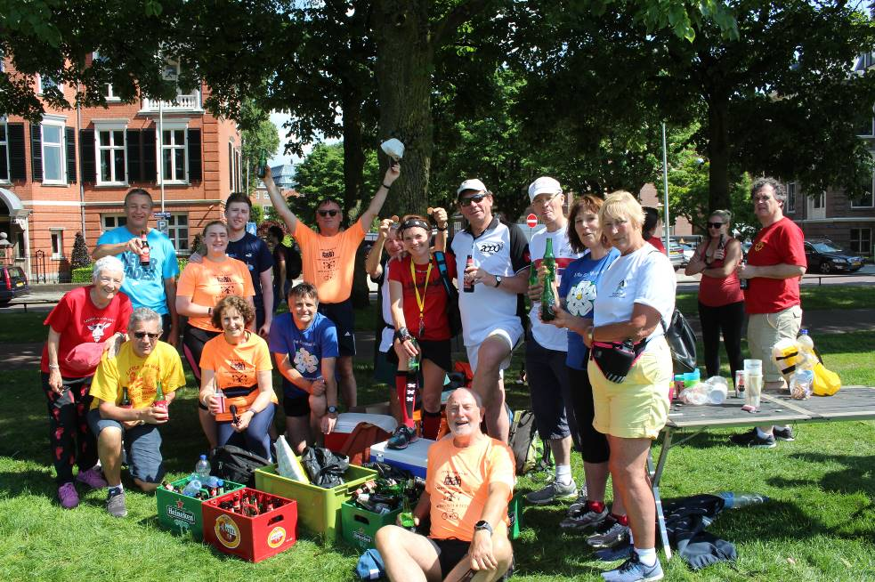 Die hards with the empties
The On On was held at the Thai Deum and the On On On was once more in the Café Wildschut.

Another great LSW Hash reunion Weekend.

Many thanks to Slippery Edge for all her efforts in organising such a great weekend. Great runs, On Ons and On On On’s.

See you all in Portsmouth in 2019.

On On
Big Bitch

